Batch RNL Manual

Contents

Introduction 2

Basics 2

Features 2

Measures 2

Requisites 2

Installation 4

UI Demo 5

1. Directory 5

2. Settings 6

3. Measures 7

4. GabRat [Optional] 8

5. GabRat [Optional] 9

5. GabRat [Optional] 10

Output 11

Pattern Analyses 11

# Introduction

## Basics

The batch RNL Chromaticity plugins are designed to make it easy for users to measure large numbers of MSPEC images with measures that are relevant to visual ecology. This system automates the following:

1. Opening of MSPECs, either in one folder or in multiple folders.
2. Conversion to cone-catch using a specified model.
3. Acuity view [optional].
4. Creation of luminance channel if there is none already, i.e. no double cone (dbl).
5. Creation of RNL chromaticity channels using specified weber fractions.
6. Measurement of specified ROIs.
7. Output of measures in a file format suitable for statistical analysis with R.

## Features

* Progress table with estimated time to completion.
* Analysis of MSPECs in their own individual folders for ease of file organisation.
* Addition of PreScripts which can modify images and ROIs prior to analyses.
* Modified acuity view for batch analysis.
* RNL chromaticity allows for disruption of colour and colour pattern metrics.
* Directional pattern metrics.
* Measurement of multiple specified ROIs for the three main categories of measurement.
* Preview mode, allowing for the system to be checked.
* Fully recordable settings, meaning the operation can be copied and changed with minor alterations.
  + (plugins/macros/record)
* Specifiable file output names for repeat operations.

## Measures

**Default Values**  
The folder name, the MSPEC name, the ROI name, the ROI area in pixels, the ROI area in mm, the major (largest) bound of the ROI in mm and the minor (smallest) bound of the ROI in mm.

**Simple Measures**The Mean, Standard Deviation, Minimum, Maximum and Kurtosis of Luminance and RNL chromaticity channels.

**GabRat**The level of edge disruption of the Luminance and/or RNL chromaticity channels.

**Pattern Measures**The Luminance and/or RNL chromaticity channel energy at different spatial scales either using Difference of Gaussian filters or orientated Gabor filters set with 2, 4 or 6 different angles.

## Requisites

Premade MSPECs with ROIs and a scalebar.

Premade Camera Model, Cone Catch model and Weber Fractions for Visual Systems.

# Installation

NB: The batch RNL tools will eventually be added to the micaToolbox by default.

* Have a copy of ImageJ with the micaToolbox ready and installed.
* Download from GitHub: <https://github.com/GeorgeHancock471/Batch_RNL_Chromaticity>
* Extract Zip file.
* Copy contents of plugins folder to the plugins folder of ImageJ.

* Check for plugins in ImageJ.

# UI Demo

## 1. Directory

Select a folder containing MSPECs or a folder containing folders with MSPECs.

**UI Image**

**Example Folder of MSPECs**

*Folder*

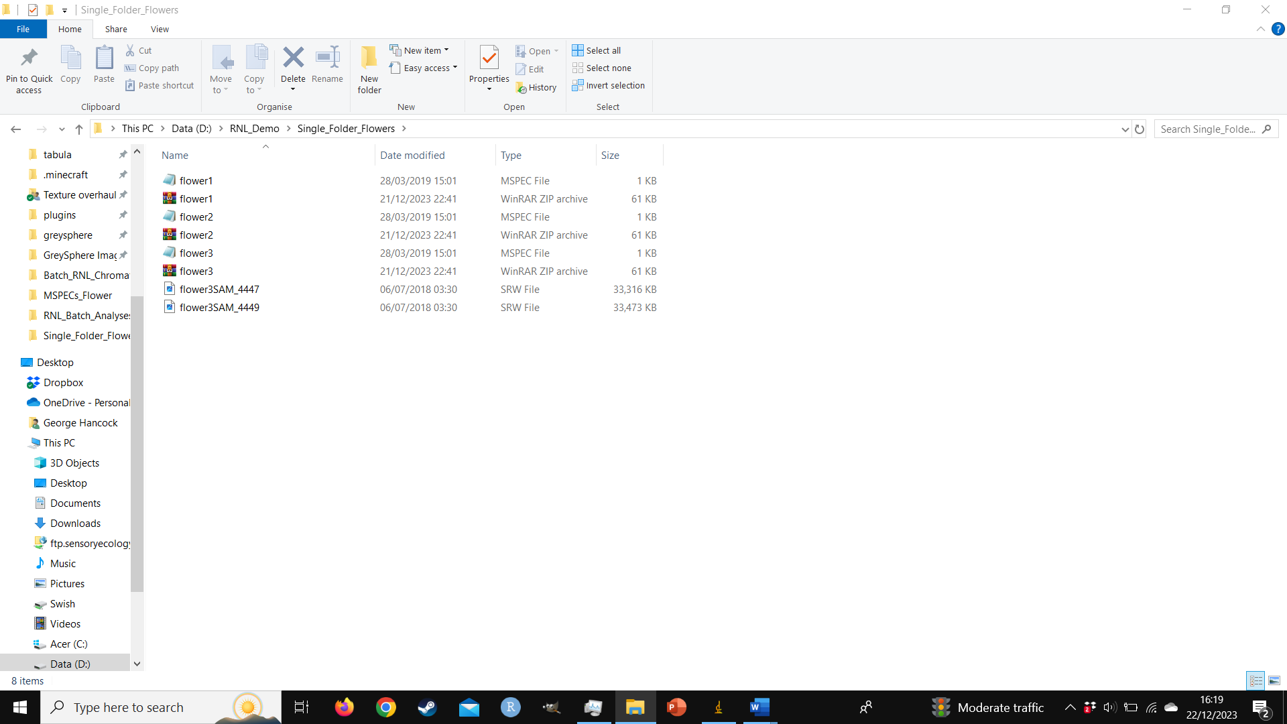

**Example Folder with Folders with MSPECs**Each one of these folders contains 1 MSPEC, but they can contain multiple.

*Folders*

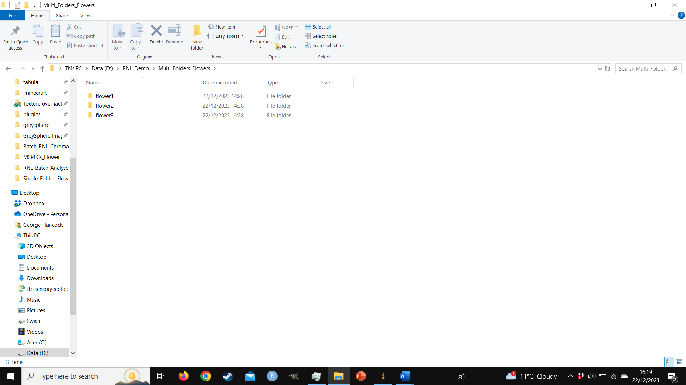

*Folder Interior*

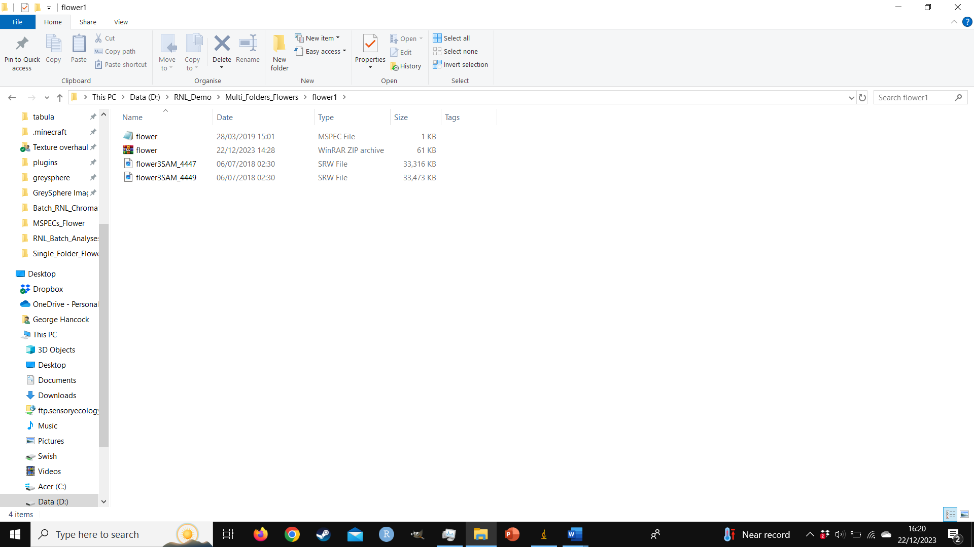

## 2. Settings

**UI Image**

**UI Breakdown**

*Settings 1*

*Organisation:* Select whether all files are in a single folder or are in multiple folders (as shown above)

* + Single MSPEC Folder, all in one folder.
  + Multiple MSPEC Folders, all in separate ‘sub’ folders (There can be multiple MSPECs per folder).
    - If there are multiple MSPECs per sub folder it will analyse each one.

*StartFolder:* Specifies which folder to start with (only useful if there was a crash).

*EndFolder:* Specifies which folder to stop at. Note if there is no MSPEC in the folder it won’t crash.

*Settings 2*

*ConeCatch:* Select the camera model from the drop-down list.

*LumChannel:* Select which channel to use for luminance.

(dbl for birds, lw mw for humans, lw for dichromat mammals and mw for insects)

*WeberFraction:* Select which Weber fraction to use. Must match the visual system chosen.

*Settings 3*

*AcuityView:* Select whether to use acuity view (Yes/No).

*Visual-acuityl:* Type the acuity in cycles per degree, e.g. human = 73 cpd [doesn’t matter if AcuityView=No].

*View-distance:* Type the viewing distance in mm [doesn’t matter if AcuityView=No].

*Settings 4*

*PreScript:* Type the name of the prescript.

* + “None”: doesn’t run anything.
  + “Create Background ROIs”: finds an ROI called ‘Target’ and adds a background circle ROI 2x the diameter of the ‘Target’.
  + You can make any prescript you like; example uses include:
    - Using the animals body length for the viewing distance in acuity view
    - Making background ROIs

*CropROI:* Crops the image to the area of a specified ROI. Useful if only a small, shared region of the image contains ROIs to measure. NB the crop ROI must always be present.

## 3. Measures

**UI Image**

**UI Breakdown**

*Measures 1*

*Mean:* Is the mean measured for the luminance and RNL chromaticity channels? Yes/No

*Standard Deviation:* Is the StdDev measured for the luminance and RNL chromaticity channels? Yes/No

*Mode:* Is the StdDev measured for the luminance and RNL chromaticity channels? Yes/No

*Min:* Is the Minimum measured for the luminance and RNL chromaticity channels? Yes/No

*Max:* Is the Maximum measured for the luminance and RNL chromaticity channels? Yes/No

*Kurtosis:* Is the Minimum measured for the luminance and RNL chromaticity channels? Yes/No

*BaseROIs:* If present, which ROIs are the measures taken for, providing they are present within the image?

* + E.g. “AllRois”: applies to all ROIs, barring the scalebar.
  + E.g. “egg1,egg2,egg3,egg4”: applies to each egg. ROIs are given as a ‘,’ delimited string.

*Measures 2*

*GabRat Luminance:* Is GabRat Edge Disruption measured for the Luminance Channels? Yes/No

*GabRat Colour:* Is GabRat Edge Disruption measured for the RNL Chromaticity Channels? Yes/No

*GabRat ROIs:* If present, for which ROIs is GabRat measured, providing they are present within the image?

* + E.g. “AllRois”: applies to all ROIs, barring the scalebar.
  + E.g. “egg1,egg2,egg3,egg4”: applies to each egg. ROIs are given as a ‘,’ delimited string.

*Measures 3*

*Pattern Luminance:* Is Pattern Energy measured for the Luminance Channels? Yes/No

*Pattern Colour:* Is Pattern Energy measured for the RNL Chromaticity Channels? Yes/No

*Pattern Orientation:* How many orientations? DoG (none), Gabor2 (2), Gabor4 (4), Gabor6 (6)

*Pattern ROIs:* If present, for which ROIs is *Pattern* measured, providing they are present within the image?

* + E.g. “AllRois”: applies to all ROIs, barring the scalebar.
  + E.g. “egg1,egg2,egg3,egg4”: applies to each egg. ROIs are given as a ‘,’ delimited string.

## 4. GabRat [Optional]

Only displayed if GabRat is enabled: <http://www.empiricalimaging.com/knowledge-base/gabrat/>

## 5. Pattern Energy Measures [Optional]

**UI Image**

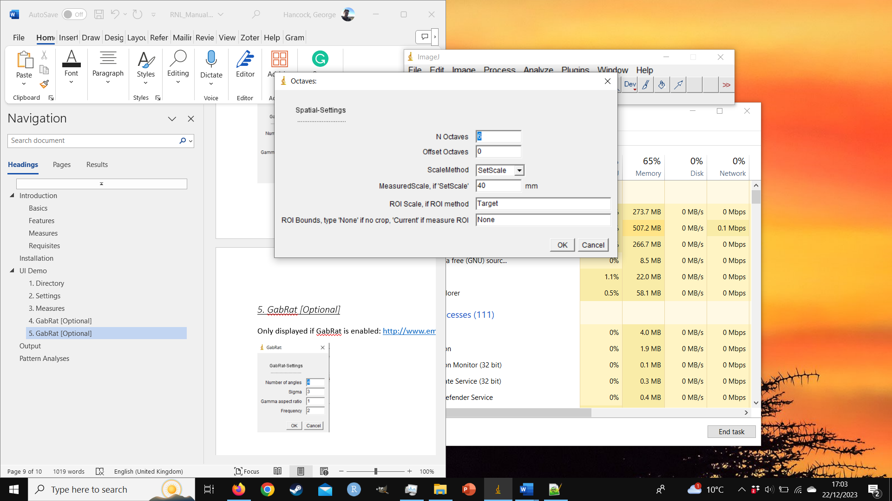

**UI Breakdown**

*N Octaves:* How many octaves are used? By default, the largest octave is 1x the scale (see below).

* + This step requires downscaling the image and so always happens last.
  + Be cautious using narrow spatial scales (high spatial frequency) with acuity view.

*Offset Octaves:* allows you to adjust octaves to end above or below the size of the ROI.

* + If you are using SetScale please leave this as 0.
  + Offsetting by +1 makes the largest scale 2x the selection size.
  + Offsetting by +2 makes the largest scale 4x the selection size.
  + Offsetting by -1 makes the largest scale 1/2x the selection size.
  + Offsetting by -2 makes the largest scale 1/4x the selection size.

*ScaleMode:* Select what determines what sets the spatial scales of the octaves.

* + SetScale: use a specified wavelength in mm.
  + ROI_Area: uses the square root of the ROI area.
  + ROI_Major: uses the major (largest) bound of the ROI.
  + ROI_Minor: uses the minor (smallest) bound of the ROI.

*MeasuredScale:* The scale in mm if using SetScale.

*ROI Scale:* The name of the ROI used for scaling if using ROI_Area, ROI_Major or ROI_Minor

*ROI Bounds:* This is important but complicated, default should be Current:

When using Difference of Gaussian and Gabor on a whole image, the pattern of the image will influence the pattern energy values. If you want to discretely compare patterns you should use “***Current”***. Using the current ROI means that ImageJ will select the ROI being measured and then run the pattern energy script made by Jolyon Troscianko, preventing bleed over from areas outside of the ROI. If, however you wish to include the effect of the background use “***None”*** or type the name of an ROI encompassing the area you are interested in. E.g. if you have a nest with eggs, select the area of the nest.

## 6. Bonus Settings

**UI Image**

**UI Breakdown**

*Test Mode:* Allows you to preview everything to make sure it is working and pause after running the first analysis.

*Delete:* If output files of the corresponding label (see below) already exist then delete them.

*Output Label:* Automatically named after the Weber Fraction used, can be adjusted for repeat analysis with different settings. With the label Bluetit 0.05 the output files will be called: Bluetit 0.05_Simple.txt, Bluetit 0.05_GabRat.txt (If enabled for 1 or more channels), Bluetit 0.05_Pattern (If enabled for 1 or more channel).txt,

* + E.g. Bluetit_500 and Bluetit_1000 representing two different viewing distances with acuity view.

## 7. Progress Table

Once the analysis has started a progress table will appear. Indicating the start time for the analysis. Once the first MSPEC has been analysed the table will then show the average time for each MSPEC to be analysed, the estimated duration the analysis will take, the estimated end time and the time remaining. While progressing the current file being analysed will be listed as well as the stage it is at e.g. opening the MSPEC.

# Output

While your analyses are being completed .txt files will be created and appended to within your chosen MSPEC directory.

## Simple Output

The first part of the output table lists the folder name the MSPECs are stored within (File), the name of the MSPEC (MSPEC), the name of the ROI the measurements are for (ROI), the area of the ROI in pixels (Area), the Area in mm (Area_mm), the length of the major bound of the ROI in mm (Major_mm) and the length of the minor bound of the ROI in mm (Minor_mm)

|  |  |  |  |  |  |  |  |
| --- | --- | --- | --- | --- | --- | --- | --- |
| FILE | MSPEC | ROI | Area | Area_mm | Major_mm | Minor_mm | …….. |
| 210405_Nest_01/ | 04.05.21_WES-01 | egg1 | 122984 | 10313.1237 | 35.8898 | 30.6811 |  |
| 210405_Nest_01/ | 04.05.21_WES-01 | egg2 | 118087 | 9902.4738 | 34.7512 | 30.4246 |  |
| 210405_Nest_01/ | 04.05.21_WES-01 | egg3 | 125905 | 10558.0713 | 37.8998 | 29.744 |  |
| 210405_Nest_01/ | 04.05.21_WES-01 | egg4 | 117878 | 9884.9476 | 35.817 | 29.467 |  |
| 210407_Nest_02/ | 04.07.21_KIN-01 | egg1 | 136169 | 13448.7901 | 46.5117 | 36.361 |  |
| 210407_Nest_02/ | 04.07.21_KIN-01 | egg2 | 149033 | 14719.3086 | 49.644 | 37.2851 |  |
| 210407_Nest_02/ | 04.07.21_KIN-01 | egg3 | 145939 | 14413.7284 | 49.6796 | 36.4849 |  |
| 210407_Nest_02/ | 04.07.21_KIN-01 | egg4 | 145285 | 14349.1358 | 46.9526 | 38.431 |  |

After that the measurements of the various channels are given: L = luminance, X (di,tri or tetra), Y (tri or tetra), Z (tetra) and Sat = Saturation. <https://www.empiricalimaging.com/knowledge-base/rnl-xyz-images/>.

|  |  |  |  |  |  |  |  |  |  |
| --- | --- | --- | --- | --- | --- | --- | --- | --- | --- |
| L_Mean | L_StdDev | X_Mean | X_StdDev | Y_Mean | Y_StdDev | Z_Mean | Z_StdDev | Sat_Mean | Sat_StdDev |
| 0.1003 | 0.0644 | 0.8839 | 2.1676 | -2.5369 | 2.6399 | -5.3716 | 2.4265 | 6.8995 | 2.4541 |
| 0.0854 | 0.0572 | 0.5527 | 2.5564 | -1.9615 | 3.1453 | -5.1144 | 2.5848 | 6.8249 | 2.6152 |
| 0.1093 | 0.0692 | 0.801 | 2.2692 | -2.456 | 2.8562 | -5.1011 | 2.2543 | 6.7547 | 2.3359 |
| 0.0927 | 0.0612 | 0.5612 | 2.4036 | -2.0497 | 2.9287 | -4.6248 | 2.4981 | 6.3582 | 2.4644 |
| 0.0649 | 0.0356 | 0.084 | 3.9598 | -0.7552 | 4.5238 | -6.4762 | 3.3504 | 8.6149 | 3.9587 |
| 0.0623 | 0.0498 | -1.1788 | 6.1644 | 0.9966 | 6.8733 | -5.7857 | 4.2686 | 10.0543 | 6.183 |
| 0.0559 | 0.0328 | -0.7034 | 5.2558 | 0.5028 | 5.3967 | -6.4605 | 3.7405 | 9.3819 | 5.0204 |
| 0.05 | 0.0315 | -1.4413 | 5.7506 | 1.8795 | 5.7704 | -5.9703 | 3.6105 | 9.4541 | 5.5926 |

## GabRat Output

The GabRat output is far simpler. This table like all of them includes the folder name (FILE) and MSPEC name (MSPEC) allowing the tables to be combined in R using the merge function e.g. ‘merge(Simple_Df, GabRat_Df)’. Doing so will remove any ROIs you didn’t measure GabRat for. Gabrat can be output for L, X, Y, Z and Sat (See Simple Measures).

|  |  |  |  |
| --- | --- | --- | --- |
| FILE | MSPEC | ROI | L_GabRat |
| 210405_Nest_01/ | 04.05.21_WES-01 | egg1 | 0.3393 |
| 210405_Nest_01/ | 04.05.21_WES-01 | egg2 | 0.3677 |
| 210405_Nest_01/ | 04.05.21_WES-01 | egg3 | 0.319 |
| 210405_Nest_01/ | 04.05.21_WES-01 | egg4 | 0.3412 |
| 210407_Nest_02/ | 04.07.21_KIN-01 | egg1 | 0.3895 |
| 210407_Nest_02/ | 04.07.21_KIN-01 | egg2 | 0.4306 |
| 210407_Nest_02/ | 04.07.21_KIN-01 | egg3 | 0.3824 |
| 210407_Nest_02/ | 04.07.21_KIN-01 | egg4 | 0.3816 |

## Pattern Output

The pattern output is by far the most complex. It is rendered as follows. As the image is downsized the area in pixels is given again (Scaled_Area). Then the pattern energy metrics are given for the different channels they are denoted as follows. When using 6 octaves with difference of gaussian and no offset you would get the following:

**DoG,** L_Energy_0.03125, L_Energy_0.0625, L_Energy_0.12500, L_Energy_0.2500, L_Energy_0.5000, L_energy_1.0000.

The final term denotes the spatial scale relative to the set scale starting from the smallest spatial scale (highest spatial frequency), which is 1/32x the size of the setscale / ROI. To calculate the sizes in advance use the following formula: 1/ 2^(n-O-sO)), where n = number of octaves, O = the current octave [1,2,…n], sO = offset.

**Gabor2**, L_Energy_0.03125_0, L_Energy_0.03125_90,….

**Gabor4**, L_Energy_0.03125_0, L_Energy_0.03125_45, L_Energy_0.03125_90, L_Energy_0.03125_135,….

**Gabor6**, L_Energy_0.03125_0, L_Energy_0.03125_22.5, L_Energy_0.03125_45, L_Energy_0.03125_67.5,….

For Gabor each scale also has an angle:  
Gabor2 (0,90),   
Gabor4 (0,45,90,135)   
Gabor6 (0,22.5,45,67.5,90,112.5,135).

An angle of 0 degrees is vertical with respect to the image and an angle of 90 degrees is horizontal with respect to the image. If you wish to compare the pattern orientations of animals, you may wish to ensure that all images are aligned to the same orientation.

If you wish to measure the energy across the spatial scale as well as the angle you will need to calculate the average energy for each octave across the angles.

**Example Gabor4 Table**

|  |  |  |  |  |  |  |  |  |  |  |
| --- | --- | --- | --- | --- | --- | --- | --- | --- | --- | --- |
| MSPEC | ROI | Scaled_Area | L_E_0.03125_0 | L_E_0.03125_45 | L_E_0.03125_90 | L_E_0.03125_135 | L_E_0.0625_0 | L_E_0.0625_45 | L_E_0.0625_90 | L_E_0.0625_135 |
| 04.05.21_WES-01 | egg1 | 4563 | 0.000037237 | 0.000035283 | 0.000038315 | 0.000038244 | 0.000034613 | 0.000036166 | 0.000038697 | 0.000037846 |
| 04.05.21_WES-01 | egg2 | 4374 | 0.000034348 | 0.000030707 | 0.000031105 | 0.000031196 | 0.00003588 | 0.000033543 | 0.000031224 | 0.000031308 |
| 04.05.21_WES-01 | egg3 | 4666 | 0.000034284 | 0.000038938 | 0.00004051 | 0.000035516 | 0.000039623 | 0.000037541 | 0.000041044 | 0.000042433 |
| 04.05.21_WES-01 | egg4 | 4371 | 0.000031621 | 0.000032347 | 0.000046366 | 0.000031289 | 0.000028958 | 0.000035705 | 0.000055432 | 0.000031529 |
| 04.07.21_KIN-01 | egg1 | 6104 | 1.79E-05 | 0.00001653 | 0.000017713 | 1.56E-05 | 0.000020474 | 0.000020843 | 0.000022336 | 0.000021394 |
| 04.07.21_KIN-01 | egg2 | 6678 | 0.000023471 | 0.00002483 | 0.000023966 | 0.000020736 | 0.000026461 | 0.000027681 | 0.000027588 | 0.000025311 |
| 04.07.21_KIN-01 | egg3 | 6541 | 1.66E-05 | 1.82E-05 | 1.90E-05 | 1.69E-05 | 0.000019105 | 0.000023786 | 0.00002287 | 0.000019912 |
| 04.07.21_KIN-01 | egg4 | 6501 | 1.39E-05 | 1.83E-05 | 2.64E-05 | 1.49E-05 | 0.000015165 | 0.000019673 | 0.000036003 | 0.000017539 |